MANIPAL GLOBAL SKILLS ACADEMY

Submitted By: Vaishak E Bhandary

MGSA_091

Rent-IT

A Car Rental Website

UNDER THE GUIDANCE OF

MRS . PRIYADARSHINI

**Introduction:**

RentIt is a car rental website developed using HTML,CSS,JAVASCRIPT and Bootstrap. RentIt is Self-Drive Car Rental Website. The concept of enjoying a car drive without actually buying a car .To book a car using RentIt you first need to signup . You should give the location ,pick up date , return date and car model which you want to drive. Then you are good to go.

**HTML:**

Hypertext markup language. It is the language that web browsers read to build a web page. It acts as a ‘blueprint’ to display data on a user’s screen. This is the basic building block of the web. Every page on the Internet is just HTML at its core.

**HTML elements:**

Elements are what we use to tell the browser how we want the data supplied to be displayed.

**Tags:**

An element consists of an opening and closing tag. The data supplied between the tags will be displayed per the instructions of the element.

The browser reads and interprets the HTML file to understand how the developer intended the data to appear on the screen.

**<p>:**

The p (“paragraph”) element. This element is meant for holding text. By default, it will render text to the screen on a new line.

**Eg: <p> hello world! </p>**

**<div>:**

The div element is a generic container. It is used primarily for grouping other HTML elements together. It is invisible by default but can be used to position or style a group of elements.

**Eg: <div>**

**<p>This is Paragraph Tag</p>**

**</div>**

**<span>:**

The span element is a generic text container. It does not create a new line like the p element does. This element is invisible by default but can be used for styling words or phrases within a larger body of text.

**Example:**

**<p>**

**This paragraph contains a <span> very important phrase </span> to be styled**

**</p>**

**<h1>-<h6>:**

These are header tags there are intended to be used as a way to present the subject matter of the page. 1 is the most important and 6 is the least important. By default, 1 will be the largest, 2 will be the next largest, and etc.

**Example : <h1> Hello <h1>**

**Attributes:**

We can include the data with special flags right inside of our tags. This is known as an attribute.

**<a>:**

The ‘a’ (“anchor”) element, allows us to create links to other web pages (or even to other areas within our own web page). You will always see the ‘a’ element used with the href attribute to tell the browser what address you want the link to point to.

**Example:**

**<a href=”http://www.google.com”>Google</a>**

**<img>:**

This element will display an image on the screen. It will always have an ‘src’ attribute which points to the address of the image to be displayed.

**Example : <img src=**[**https://car.jpg**](https://car.jpg)**/>**

**<ul> and <ol>:**

This element represents an “unordered list”. This is the parent element and will contain list items. There is also an ordered list <ol>.

**<li>:**

The companion to the <ul> and <ol>. These elements represent the items to appear in the list. Any other elements can appear in an li.

**Example:**

**<ul>**

**<li>**

**<span>List Item one</span>**

**</li>**

**</ul>**

**CSS:**

CSS stands for Cascading Style Sheets. It allows us to add color and style to our web pages.

There are two ways of including CSS in our HTML:

1. We can write our CSS directly between two style tags:

<style>

/*<!-css written here-*/

</style>

1. We can link to an external CSS file using the link element. This element will include two attributes: rel and href. rel will refer to the type of file we are linking: in this case, “stylesheet”, and the href will point to the location of the file.

<head>

<link rel=”stylesheet” href=”./style.css”/>

**CSS Selectors:**

You can select all elements of a certain type: p, div, body, and etc. Or you can apply a class or id to each individual element. We apply these selectors to the HTML tags themselves in the form of an attribute:

**<div id=”car”></div>**

**<div class=”divclass”></div>**

**Ids:** are titles that can only appear on a single element.

**Classes**: on the other hand can apply to multiple elements

**Individual elements**: We do not need to add anything to use every element of a certain type as a selector.

**Styling Rules (Syntax) :**

Inside of our style tags, we will insert the rules. Classes will always begin with ., and Ids will always begin with #. Elements will begin with neither and just have the element name. After the name of the selector, we will use braces to hold our rules to that one selector.

**<style>**

**body{}**

**.divClass{}**

**#divId{}**

**</style>**

Within the braces, we will then have the name of the property, a colon(“:”), and the value of the rule. This will be followed by a semicolon(“;”).

**Example:**

**div {**

**styling_property:Value of rule;**

**}**

**background or background-color:**

Background can be set to a variety of rules. Most common would be setting the background to a color or an image. Both are displayed below. If you want to be more explicit, you can use the property background-color to only set the color of the background.

**Color :** is used for text only. It will set the color of your text.

**font-size:**

We can’t use width or height for text, but we can determine the size of the font used. You can use any size unit here that you would use with a font in a word processor (px, em, in, and etc). Px or pixel is the most popular.

**height and width:**

We can tell the browser exactly how wide and how tall we want our element (content) to be. This is used in divs, imgs, and other height-based elements (in order to determine the size of text, we will need to use a different styling property). Size values can be in lots of different measures, but the most common is the pixel (“px”).

**Margin:**

The margin is an invisible area that surrounds your element. This is the outermost area in what we refer to as the box model

**Border:**

Border will set a border around your element. You can determine the size, color, and style of the border. It will be set up in this order: width, style, color. The border is outside the padding, but inside the margin.

**Padding:**

The padding is the transparent area between the border and the content. It is very similar to the margin.

**JAVASCRIPT:**

JavaScript is the programming language that lets the Internet work. The Internet would be nothing without JavaScript .

JavaScript is the third of the major building blocks of a web page. Without it, we wouldn’t have the dynamic content.

JavaScript, being the de-facto language of the Internet, is usually run from within an Internet browser. One way to run your JavaScript, most JavaScript is run from a file with the extension of .js (e.g., fileName.js) and loaded into your browser via the script tag in your HTML.

**Variables:**

**Var:**

var is the ES5 way of declaring a variable. This is a generic variable keyword.

**Let:**

let is a new ES6 variable keyword. This will assign a variable much like var, but with a little bit different behavior. Most notably, it differs by creating “block level scope”.

**Const:**

const is also new in ES6. A const variable is a variable that cannot be changed. It’s short for “constant”.

**Primitive Data Types (String, Number, Boolean):**

The term ‘primitive data type’ refers to the fact that these are the most basic data types in the language. All other data types (which we will learn about in later lessons) use these types.

**Strings:**

Strings are blocks of text. They will always be defined with quotation marks around them, either single or double. Any text with quotes around it is a string.

**Numbers:**

Numbers are just that, numbers. Numbers do NOT have quotes around them. They can be negative as well. JavaScript does have a limitation on the size of a number (+/- 9007199254740991), but only very rarely will that limitation come up.

**Booleans:**

Booleans come from low-level computer science. It is a concept that powers binary code and the very core of computers. You may have seen binary code in the past (e.g., 0001 0110…). That is Boolean logic. It essentially means you have two choices, on or off, 0 or 1, true or false. In JavaScript, we use Booleans to mean true or false. This may seem simple at first but can get complicated later on.

**Math Operators:**

One of the first jobs a computer had was to compute numbers. In JavaScript, we have built-in math operators that work exactly as they do on your calculator.

+ — * / = %

**Properties and Methods:**

Primitive data types (and other data types) have built-in functionality known as properties and methods.

**Properties:**

Properties allow us to access data from a data type. There are many different properties on every data type that will give you a bit of information about that specific object.

One we will look at here is the length property of a string. It will give us the length of the string, as in how many characters are in the string (spaces count).

**Methods:**

Methods allow us to manipulate a data type. Methods are different from properties in that they need to have parentheses on the end.

The method we will look at here is the toString method. It will convert a Number or Boolean to a string.

**Functions:**

Functions allow us to perform many computations and return a final product. When we run a computer program, we are running a series of functions, and reading or manipulating what they return. You may not have realized this, but we have already worked with a type of function: a method.

**Anatomy of a Function:**

**Function myFunc(){**

**}**

A function will start with the function keyword. This tells whatever is running your program that what follows is a function and to treat it as such. After that comes the name of the function. We like to give functions names that describe what they do. Then comes open and close parentheses. And finally, open and close brackets. In between these brackets is where all of our function code will go.

**Control Flow:**

A computer is reading and executing our code, we want code to run only if something is true or not. This is known as control flow.

when you want to check for a specific condition. With the IF condition, the inner code block is executed if the condition provided is satisfied.

**Syntax:**

**if (condition) {**

**//code block to be executed if condition is satisfied**

**}**

**IF-ELSE:**

an extended version of IF. When you want to check a specific condition and two

**Syntax:**

**if (condition)**

**{**

**// code to be executed of condition is true**

**}**

**else {**

**// code to be executed of condition is false**

**}**

As you can see, when the condition is satisfied in IF-ELSE, the first block of code will be executed and if the condition isn’t satisfied, the second block of code will be executed.

**SWITCH:**

A switch statement is similar to IF and is of use when you need to execute one code out of the multiple code block execution possibilities, based on the result of the expression passed. Switch statements carry an expression, which is compared with values of the following cases and once a match is found, code associated with that case executes.

**Syntax:**

**switch (expression) {**

**case a:**

**//code block to be executed**

**Break;**

**case b:**

**//code block to be executed**

**Break;**

**case n:**

**//code block to be executed**

**Break;**

**default:**

**//default code to be executed if none of the above case is executed**

**}**

The above code contains an expression at the very beginning, which is check and compared with the cases included. If the expression passed matches with the case a, the code block inside the case is executed. The same applies for case b and n, and when the expression passed matches with none of the cases mentioned, it code enters default case and the code under default case is executed.

**WHILE:**

one of the control flow statement, which executes a code block when the condition is satisfied. But unlike IF, while keeps repeating itself until the condition is satisfied. Difference between IF and while can be, IF executes code ‘if’ the condition is satisfied while the while keeps repeating itself until the condition is satisfied.

**Syntax:**

**while (condition)**

**{**

**//code block to be executed when condition is satisfied**

**}**

**DO-WHILE:**

Similar to a while loop, with a twist that keeps a condition at the end of the loop. Also known as Exit Control Loop, DO-WHILE executes the code and then checks for the condition.

**Syntax:**

**while**

**{**

**//code block to be executed when condition is satisfied**

**} (condition)**

If the condition at the end is satisfied, the loop will repeat.

**FOR:**

a for loop will execute a code block for a number of times. Compared to other loops, FOR is shorter and easy to debug as it contains initialization, condition and increment or decrement in a single line.

**Syntax:**

**for (initialize; condition; increment/decrement)**

**{**

**//code block to be executed**

**}**

With initialize, it starts the loop, here a declared variable is used. Then the exit condition for the loop is checked in condition part. When this condition returns true, the code block inside is executed. When, in case, if the condition returns false or fails, it goes to increment/decrement part and the variable is assigned an updated value. Values are updated until the condition is satisfied.

**BOOTSTRAP:**

Bootstrap 5, this is the most popular front-end HTML, CSS, and Javascript framework. in the past bootstrap has released many versions like v1, v2, v3, v4, and subversions. and for now bootstrap release version 5.

Steps:

* Get started by including Bootstrap’s production-ready CSS and JavaScript via CDN without the need for any build steps.
* Create a new index.html file in your project root. Include the <meta name="viewport"> tag as well for proper responsive behavior in mobile devices.

<!doctype html>

<html lang="en">

<head>

<meta charset="utf-8">

<meta name="viewport" content="width=device-width, initial-scale=1">

<title>Bootstrap demo</title>

</head>

<body>

<h1>Hello, world!</h1>

</body>

</html>

* Include Bootstrap’s CSS and JS. Place the <link> tag in the <head> for our CSS, and the <script> tag for our JavaScript bundle (including Popper for positioning dropdowns, poppers, and tooltips) before the closing </body>.

<!doctype html>

<html lang="en">

<head>

<meta charset="utf-8">

<meta name="viewport" content="width=device-width, initial-scale=1">

<title>Bootstrap demo</title>

<link href="https://cdn.jsdelivr.net/npm/bootstrap@5.2.0/dist/css/bootstrap.min.css" rel="stylesheet" integrity="sha384-gH2yIJqKdNHPEq0n4Mqa/HGKIhSkIHeL5AyhkYV8i59U5AR6csBvApHHNl/vI1Bx" crossorigin="anonymous">

</head>

<body>

<h1>Hello, world!</h1>

<script src="https://cdn.jsdelivr.net/npm/bootstrap@5.2.0/dist/js/bootstrap.bundle.min.js" integrity="sha384-A3rJD856KowSb7dwlZdYEkO39Gagi7vIsF0jrRAoQmDKKtQBHUuLZ9AsSv4jD4Xa" crossorigin="anonymous"></script>

</body>

</html>

* You can also include Popper and our JS separately. If you don’t plan to use dropdowns, popovers, or tooltips, save some kilobytes by not including Popper.

<script src="https://cdn.jsdelivr.net/npm/@popperjs/core@2.11.5/dist/umd/popper.min.js" integrity="sha384-Xe+8cL9oJa6tN/veChSP7q+mnSPaj5Bcu9mPX5F5xIGE0DVittaqT5lorf0EI7Vk" crossorigin="anonymous"></script>

<script src="https://cdn.jsdelivr.net/npm/bootstrap@5.2.0/dist/js/bootstrap.min.js" integrity="sha384-ODmDIVzN+pFdexxHEHFBQH3/9/vQ9uori45z4JjnFsRydbmQbmL5t1tQ0culUzyK" crossorigin="anonymous"></script>

Hello, world! Open the page in your browser of choice to see your Bootstrapped page.

**RentIT : A Car Rental Website (Project)**

**Files Configuration:**

Project File configuration consists of :

1. Images folder : which contaions all the images used in the Project.
2. Index.html : contains the HTML structure part of Home page.
3. Index.css: contains CSS part of Home page.
4. Login.html : contains login page HTML and inline CSS and JavaScipt embedded on it.
5. Signup.html: contains Signup page HTML and inline CSS .
6. Main.js: Contains the validation javascript code inside it.

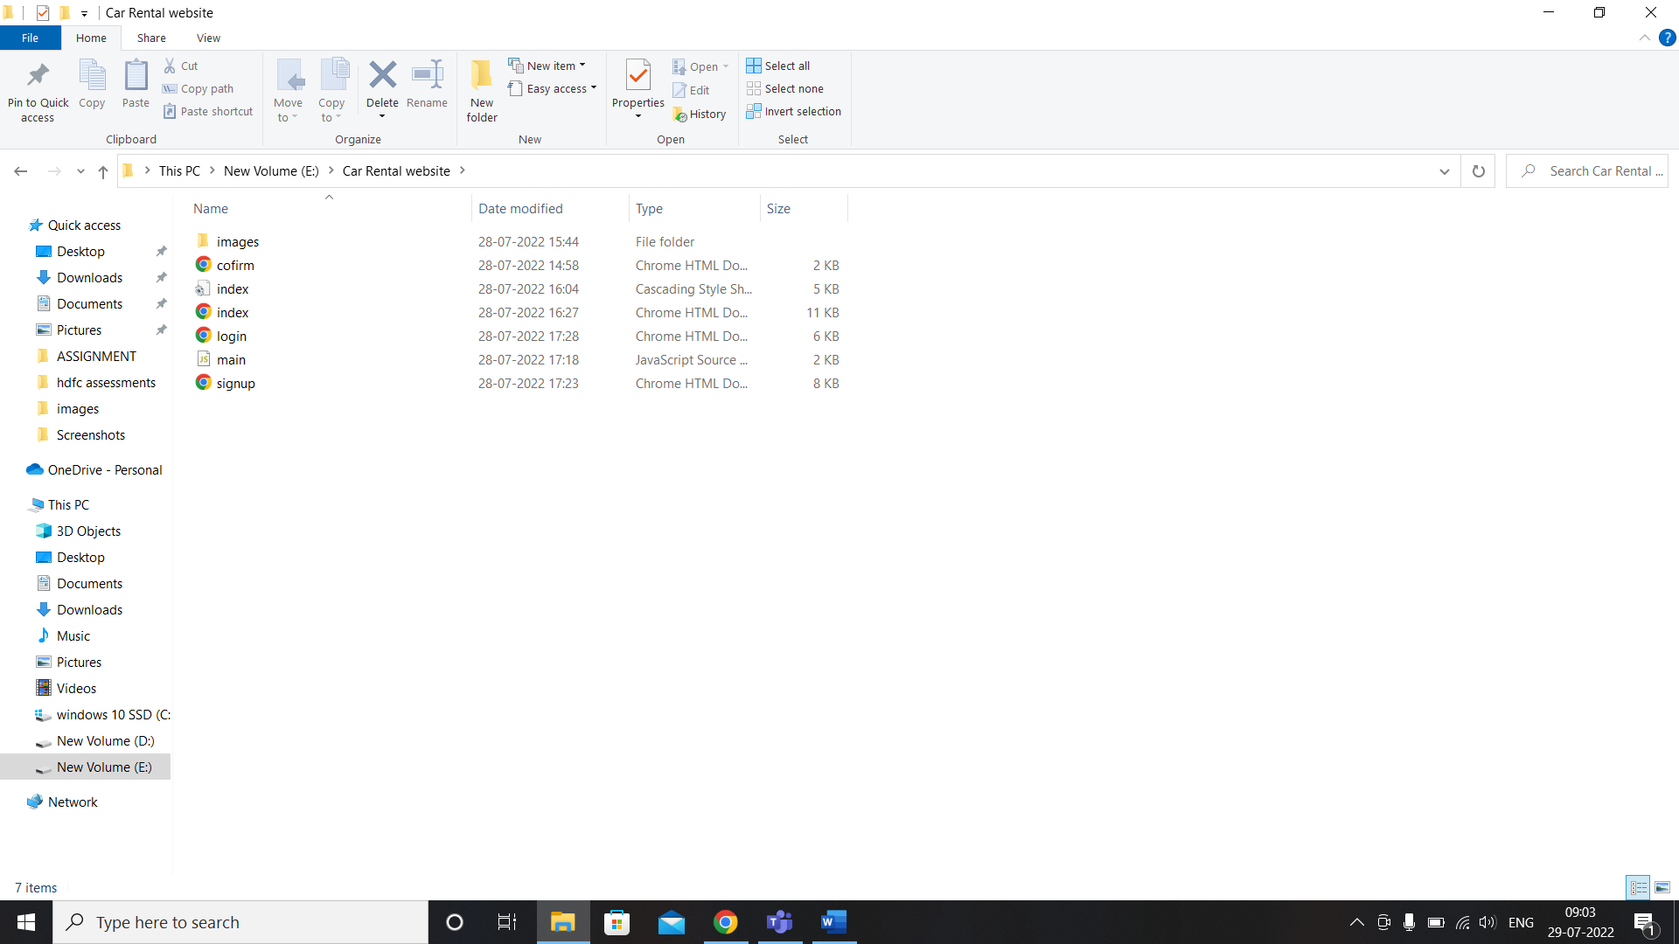

Fig 1 : Folder and File configuration .

**Pages in website:**

1. **Home page:**

Home page is initial page which displays to the user. It contains the navigation bar . And fields to enter location, pickup date and return date.

**Screenshots:**

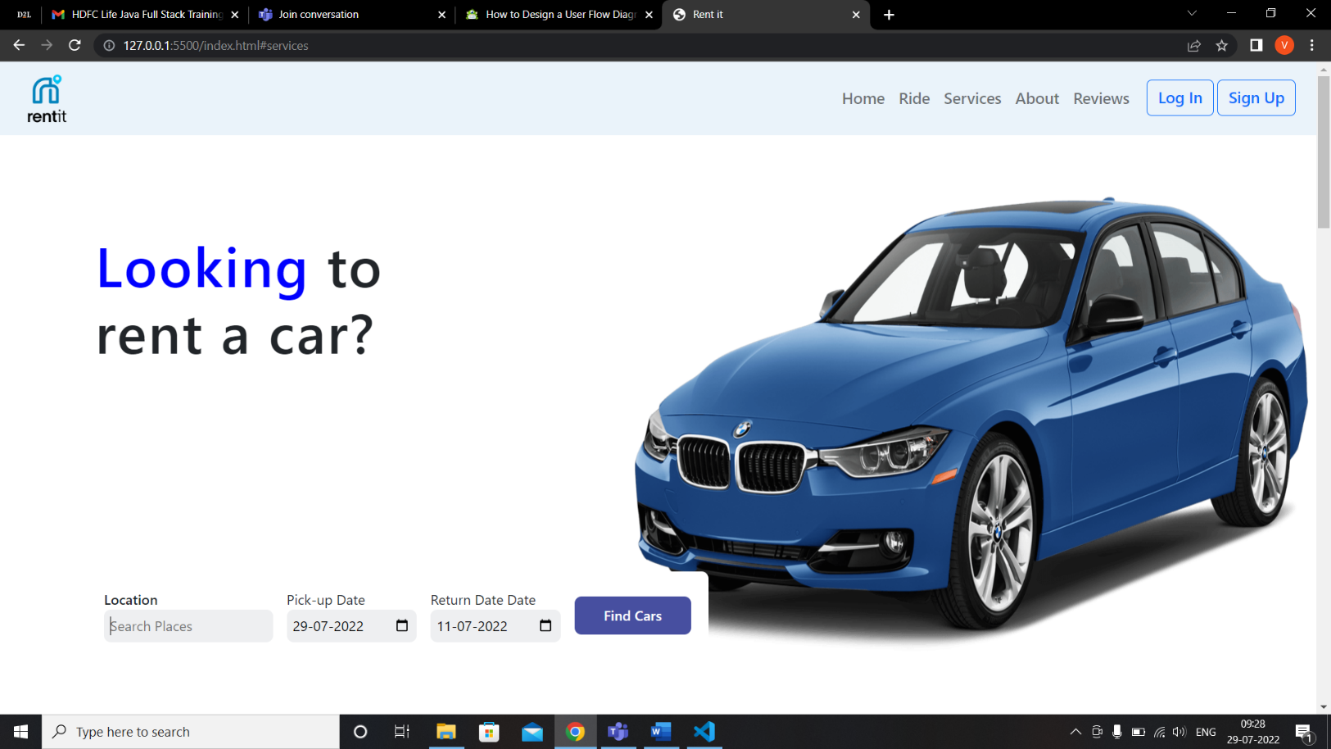

1. **Ride:**

This page shows the 3 simple steps to book a rental car .

**Screenshots:**

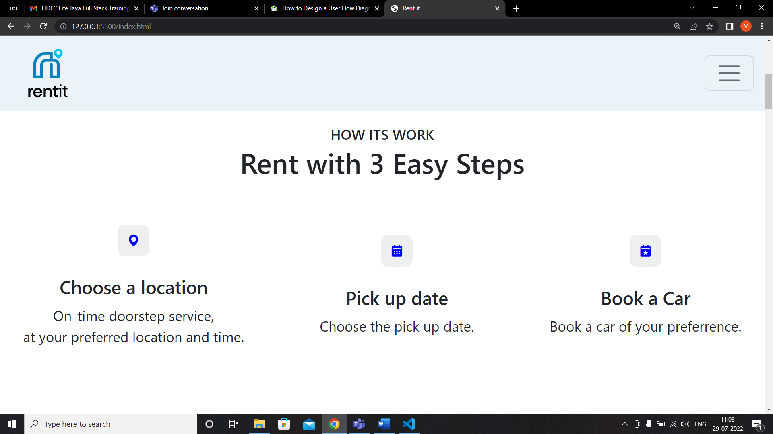

1. **Services:**

Services page shows the cars available for the rent. Along with the pricing and rent now option.

**Screenshots:**

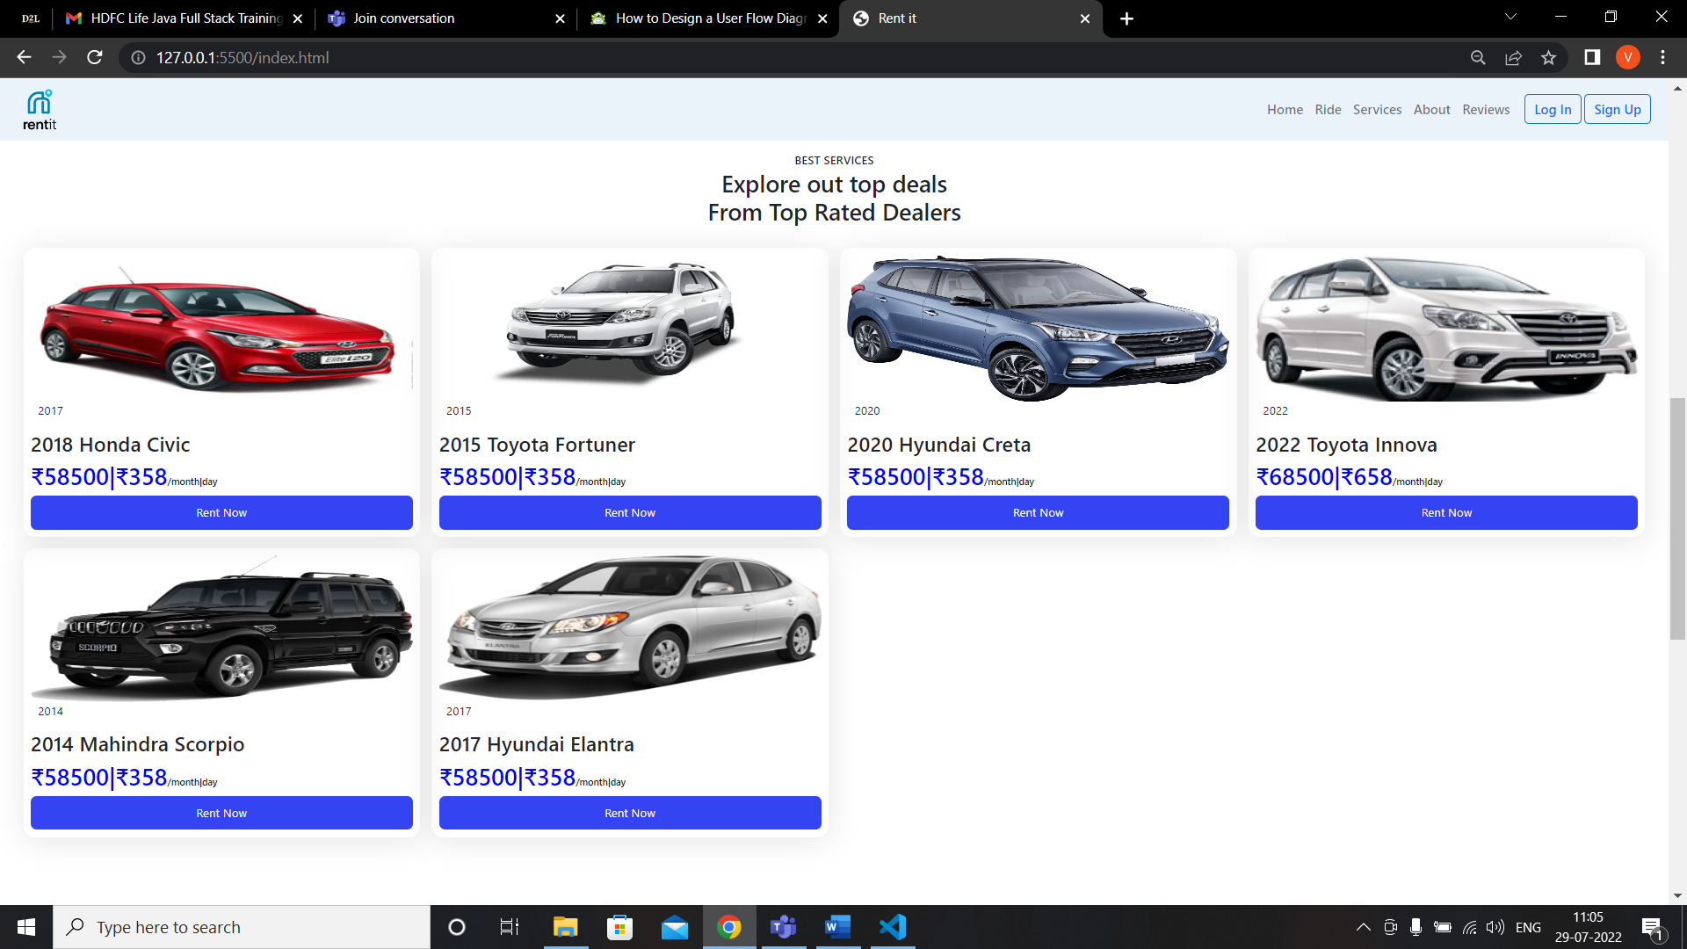

1. **About Us :**

The about us page contains the brief description of RentIt website what it does.

**Screenshots:**

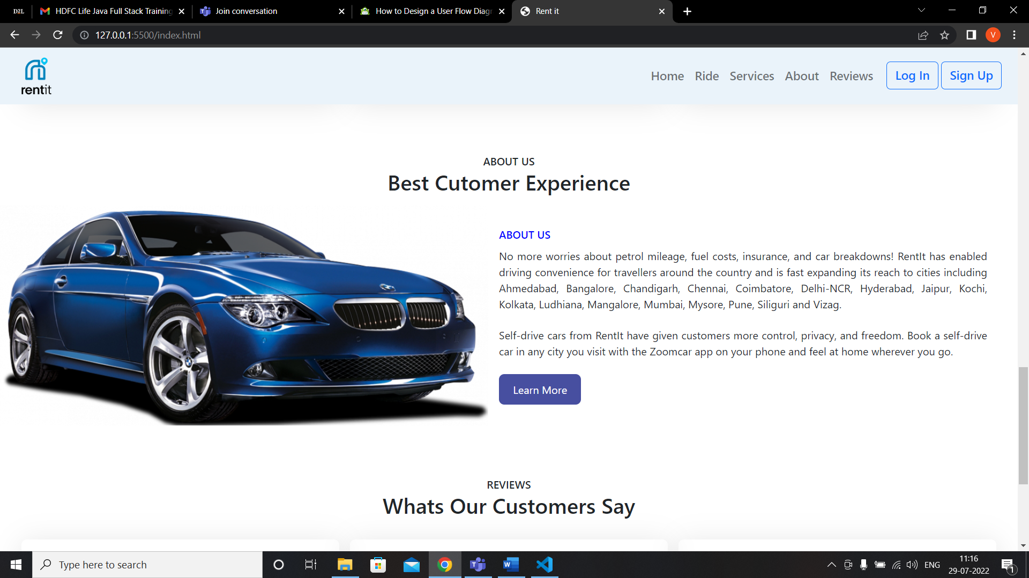

1. **Reviews:**

**Reviews page displays the review of the customers about the website.**

**Screenshots:**

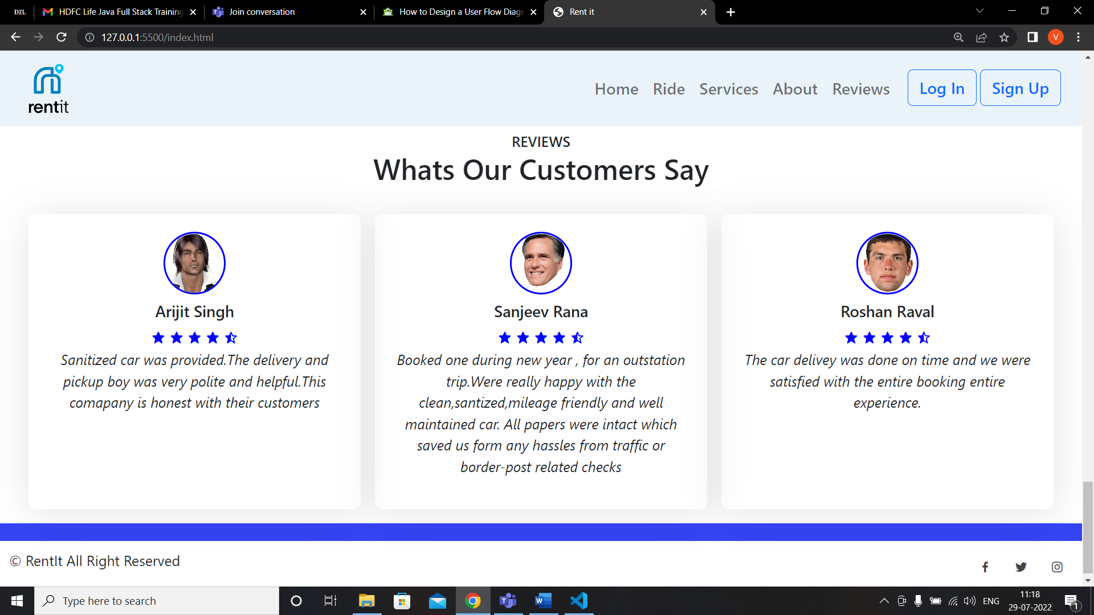

1. **Sign In:**

Where the user can enter the required fields as shown below and create his/her account.

**Screenshots:**

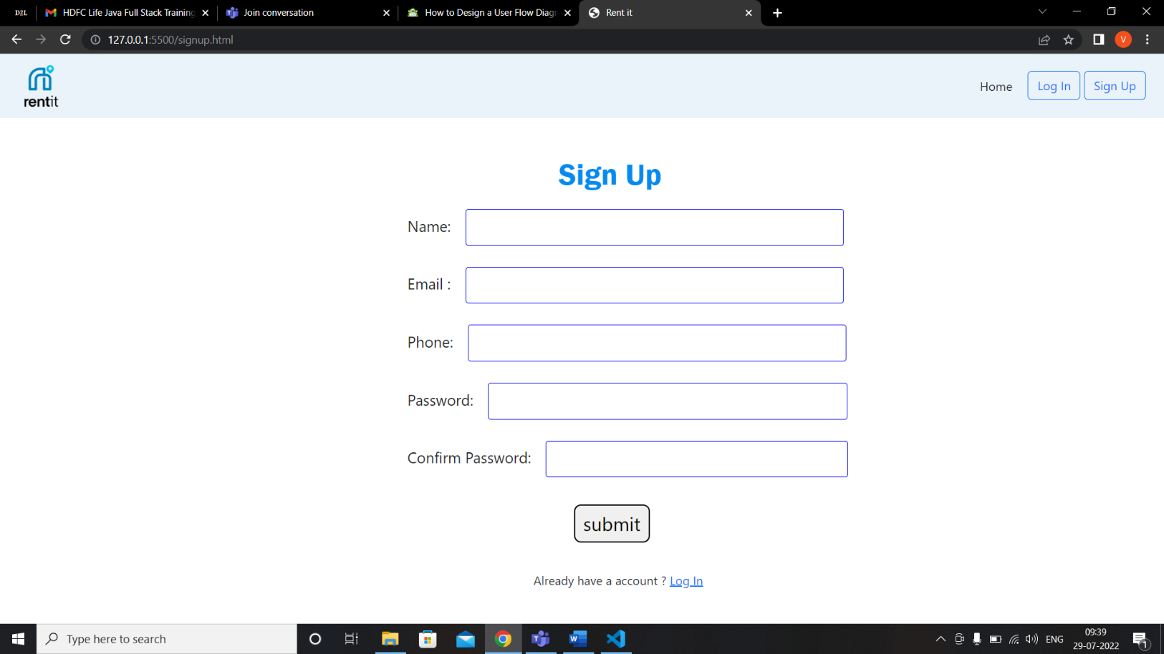

**Sign Up Validation Screenshots:**

* **Name field should contain atleast 5 characters:**

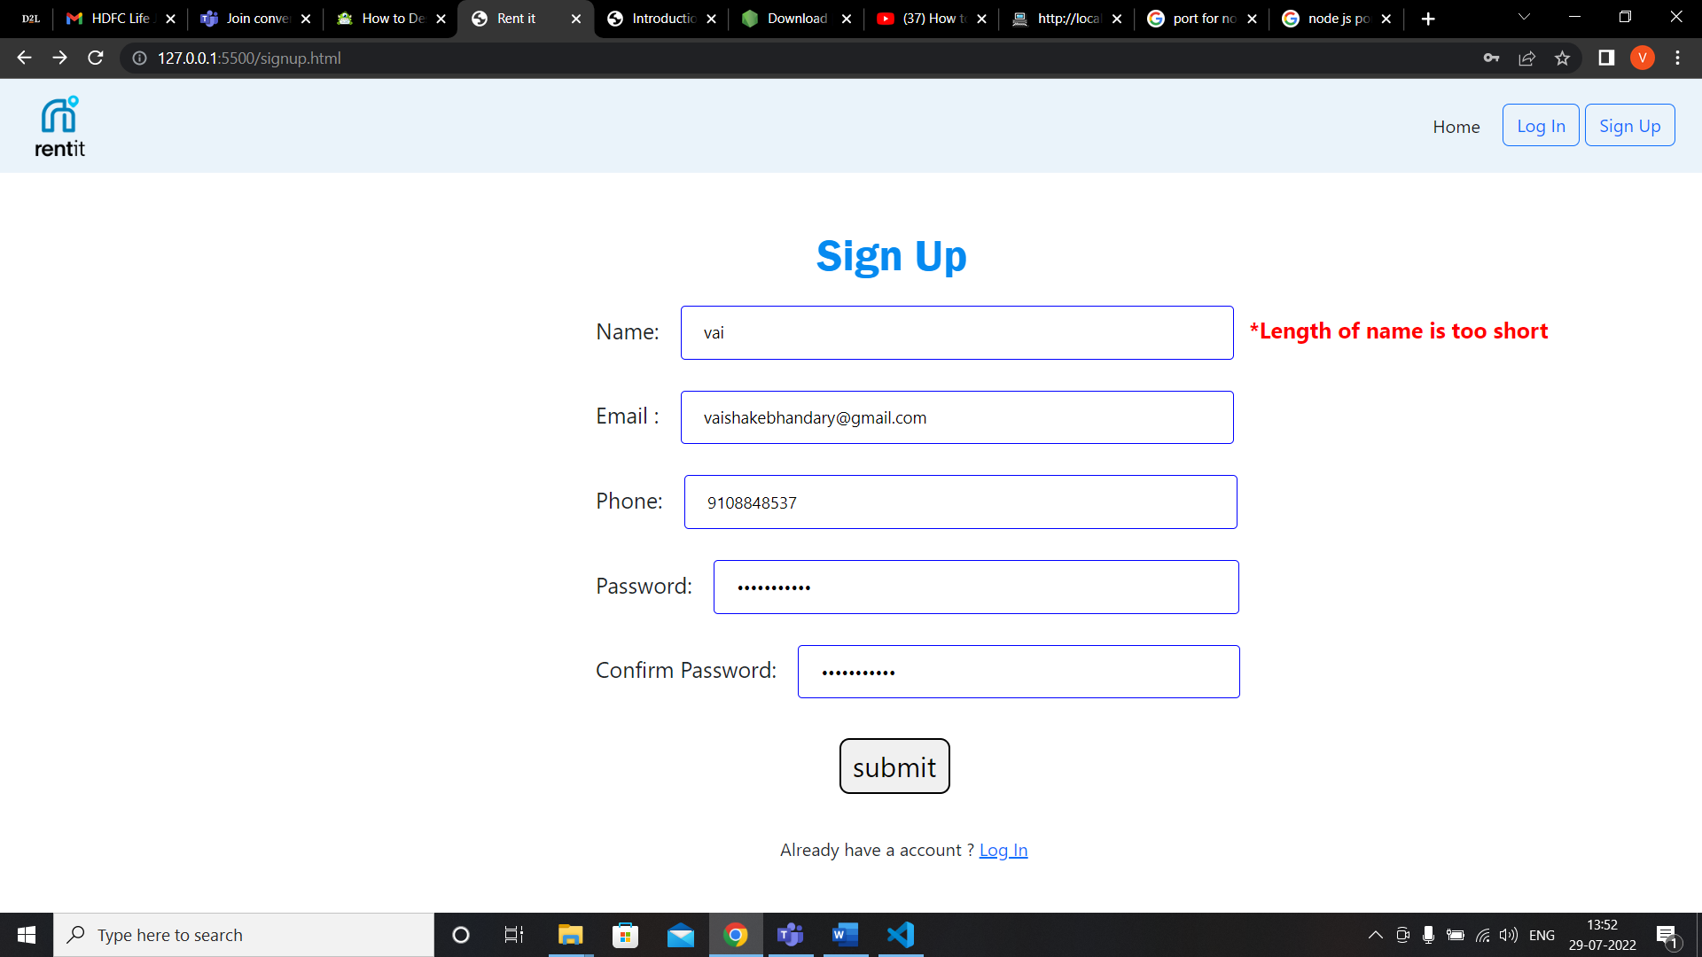

* **Email should be in correct format:**

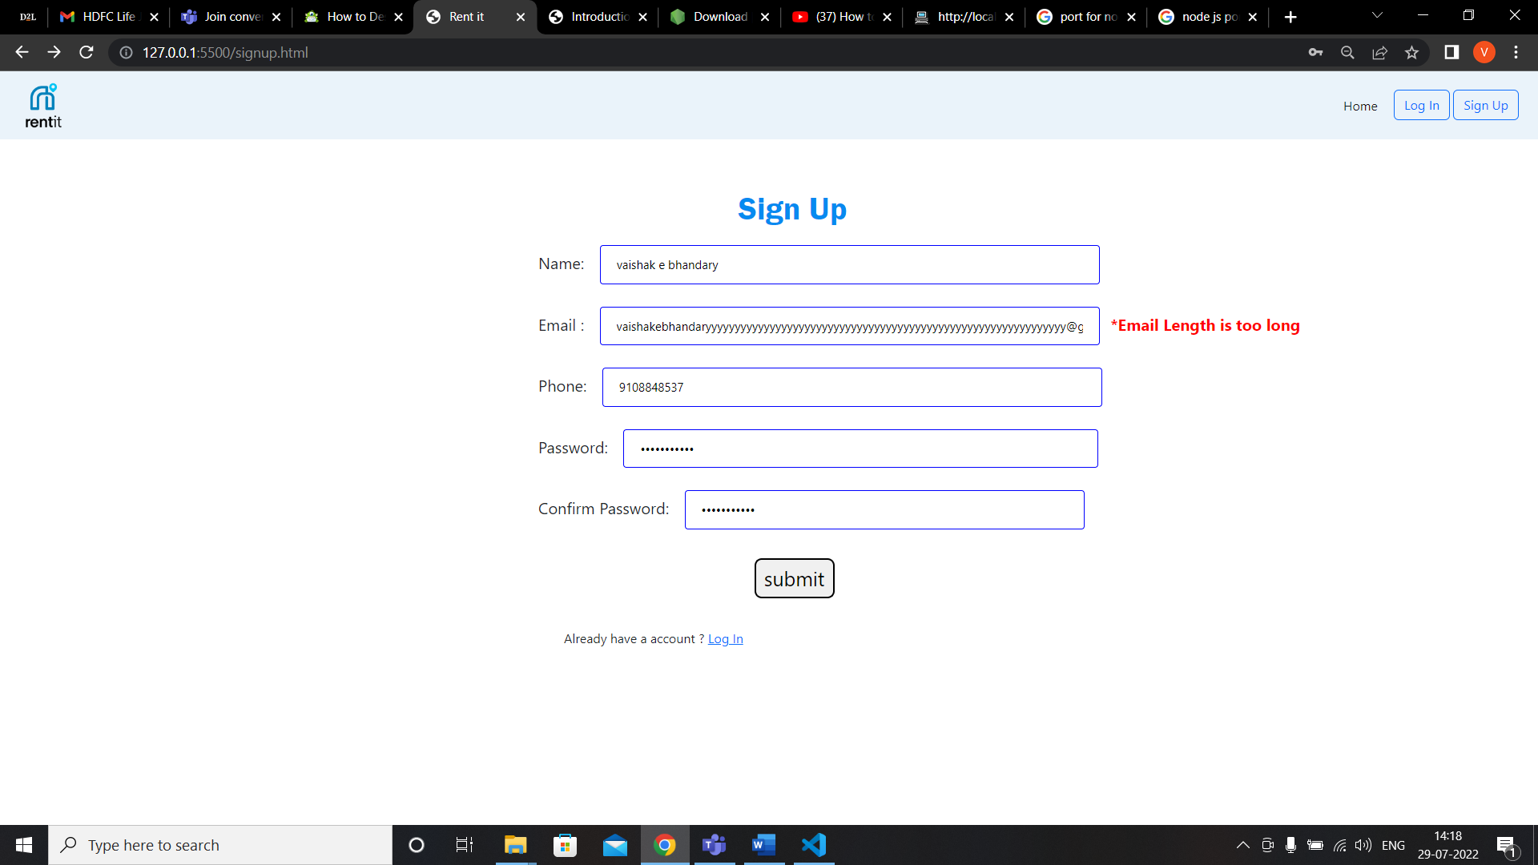

* **Email should not exceed 30 characters:**

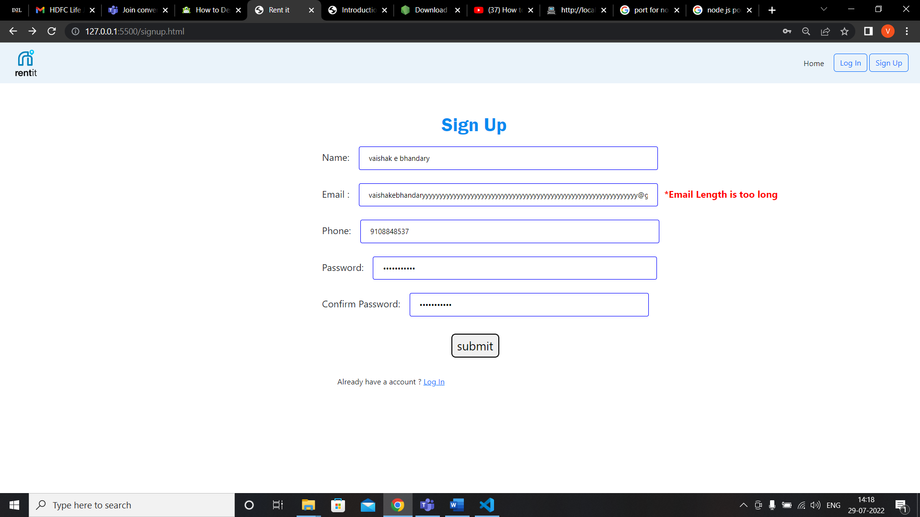

* **Phone number should be of 10 numbers:**

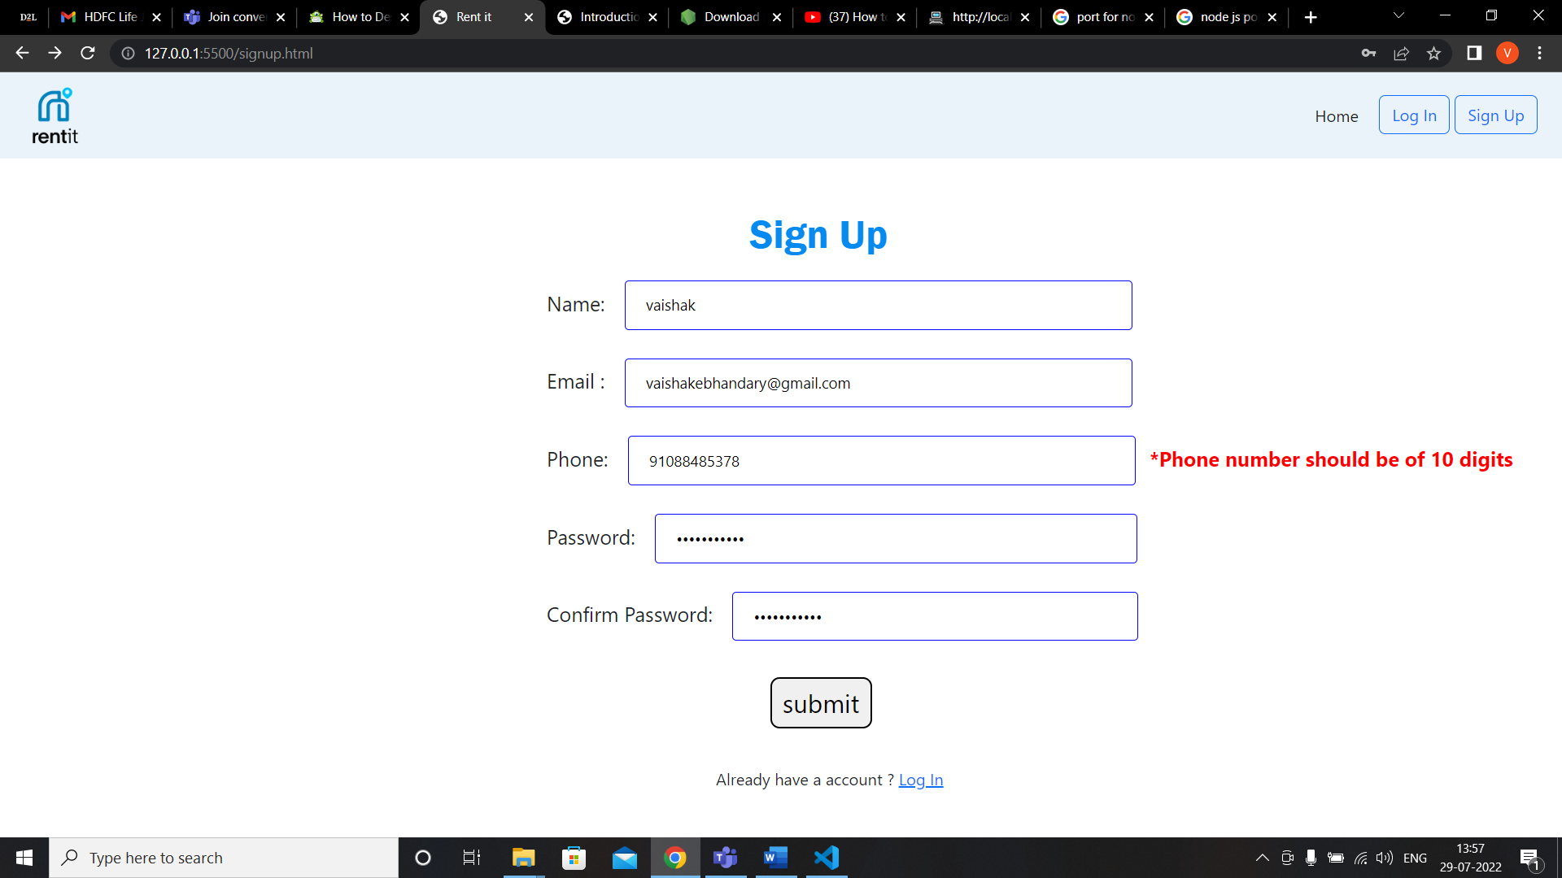

* Password should contain one uppercase letter, one numeric letter and one special character :

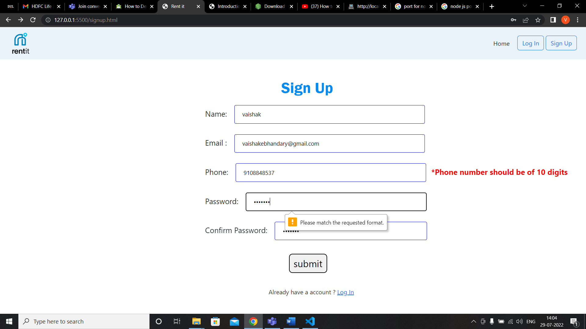

* **Password should be atleast 6 characters long:**

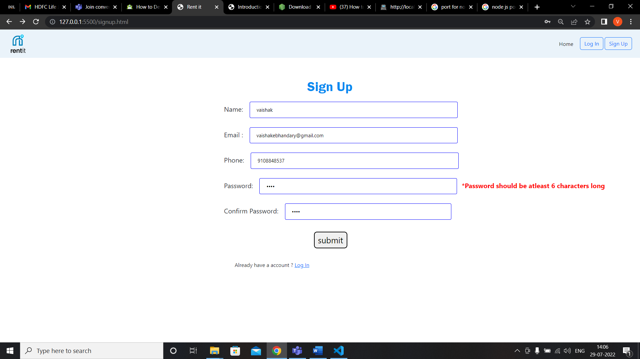

* **Password and confirm password should match :**

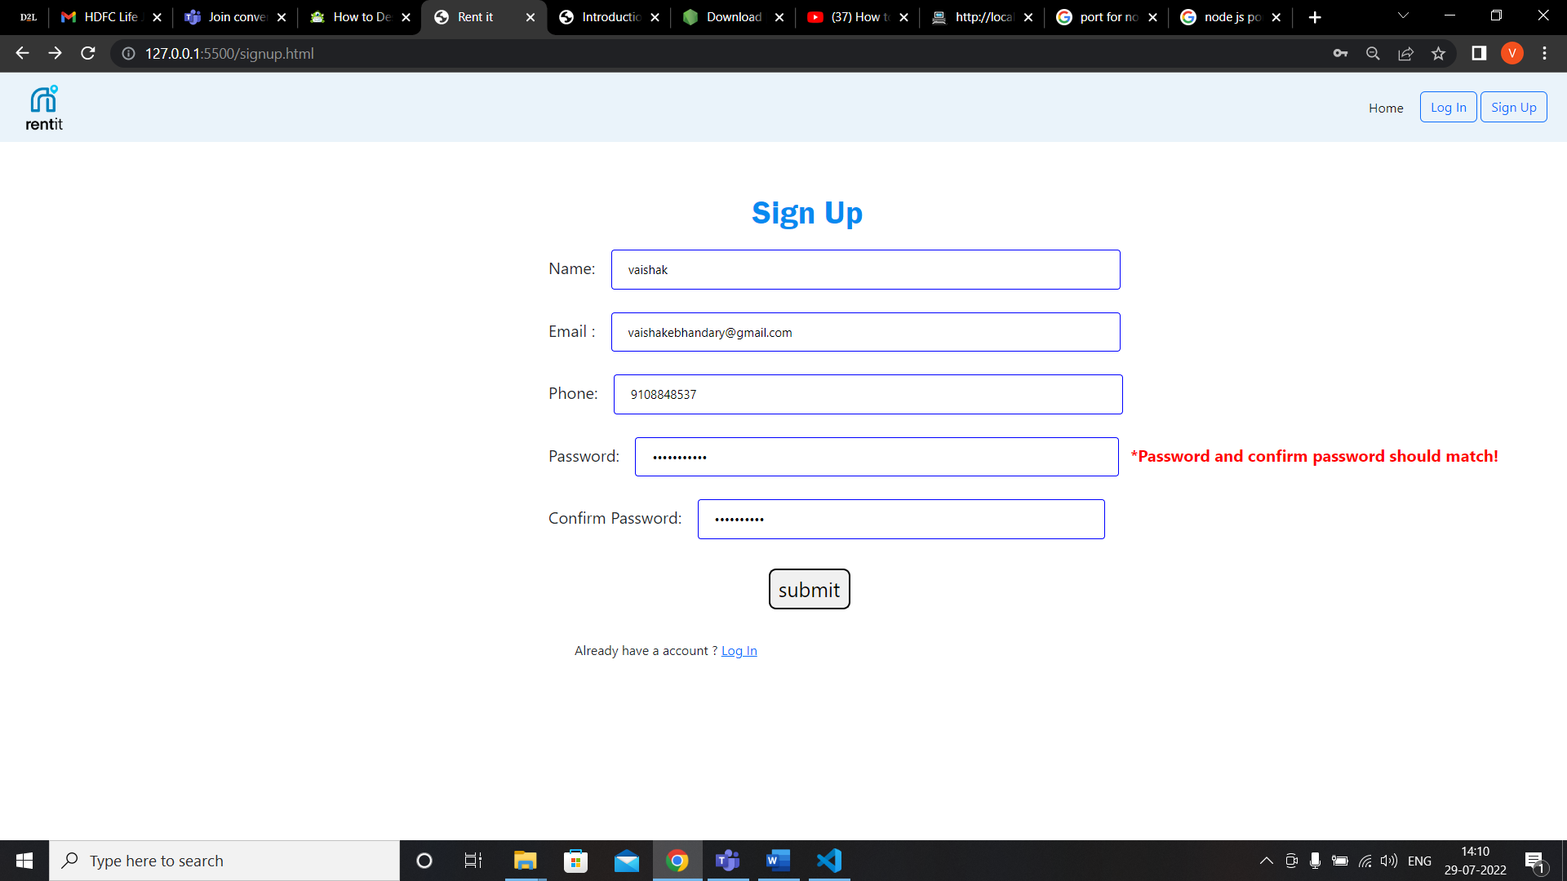

1. **Log In:**

**If the customer wants to rent a car he has to login with the current email and password only then he is allowed to log onto the website.**

**Screenshots:**

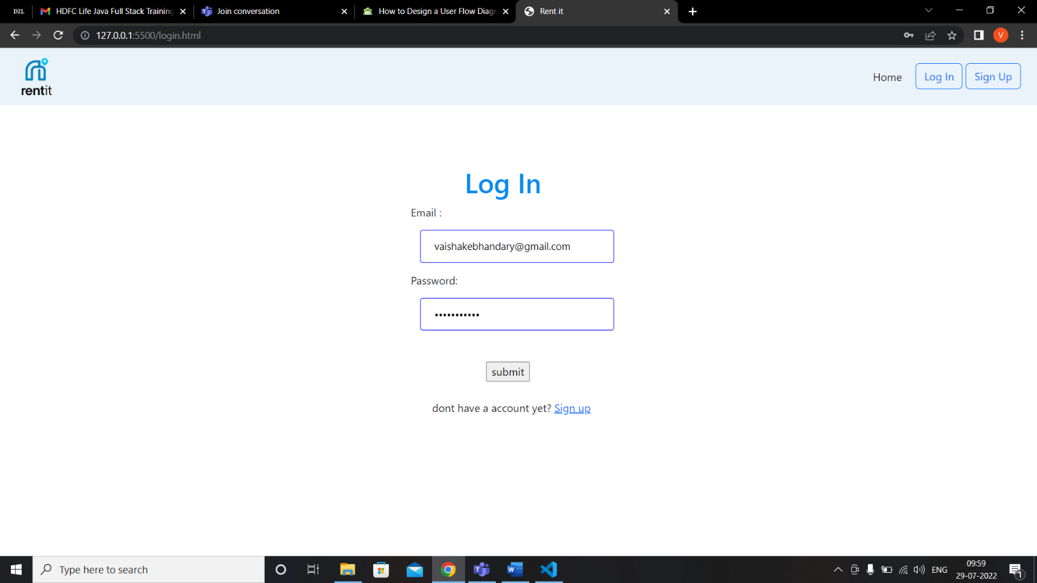

**Login Validation Screenshots :**

* Password should contain one uppercase letter, one numeric letter and one special character :

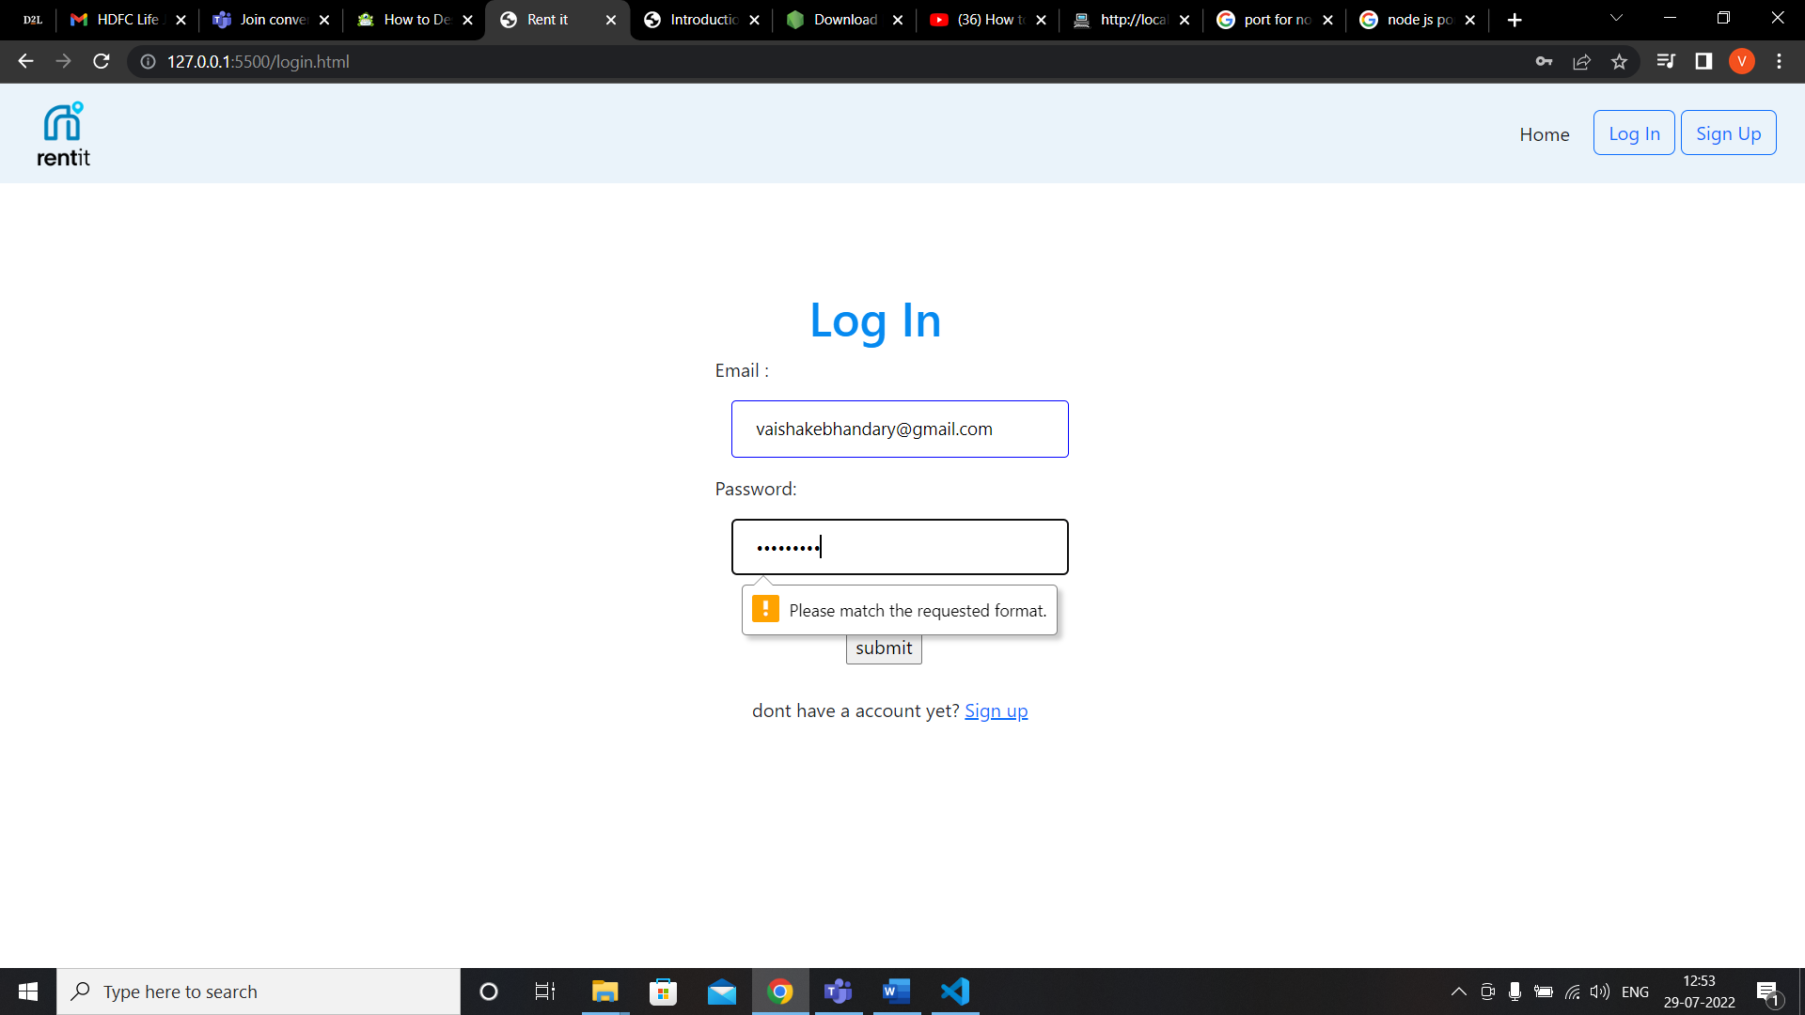

* **Password should be atleast 6 characters long:**

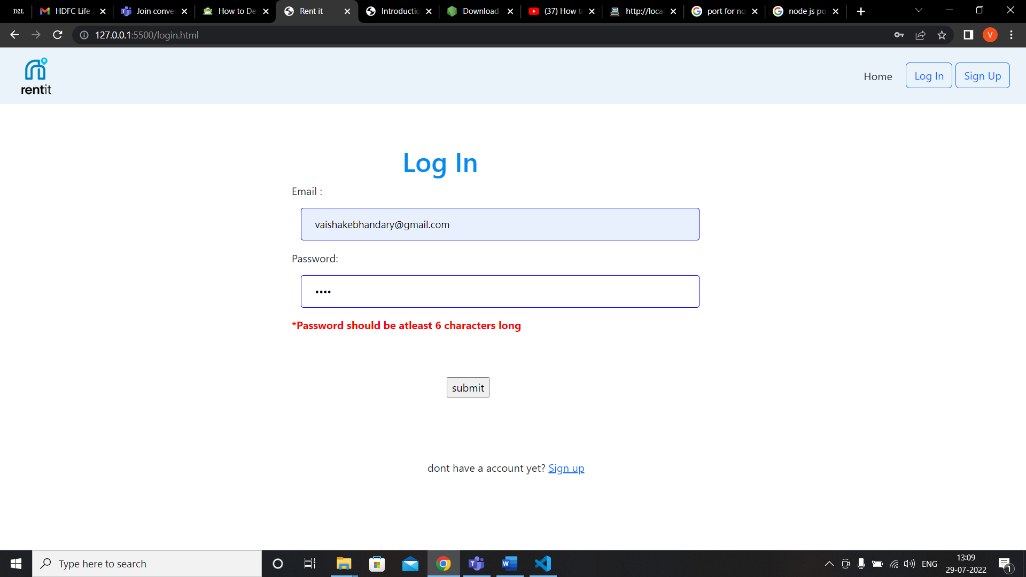

* **Email should be in correct format:**

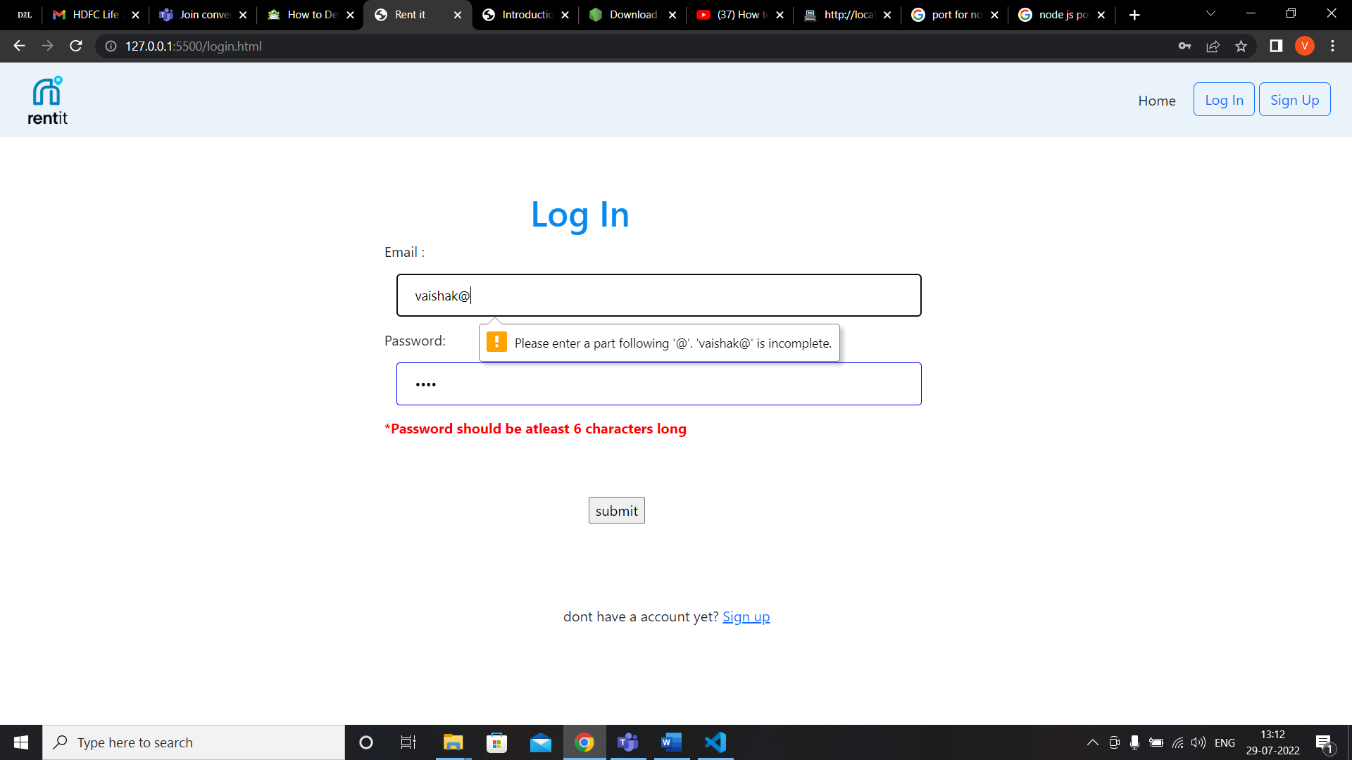

* **Email should not exceed 30 characters:**

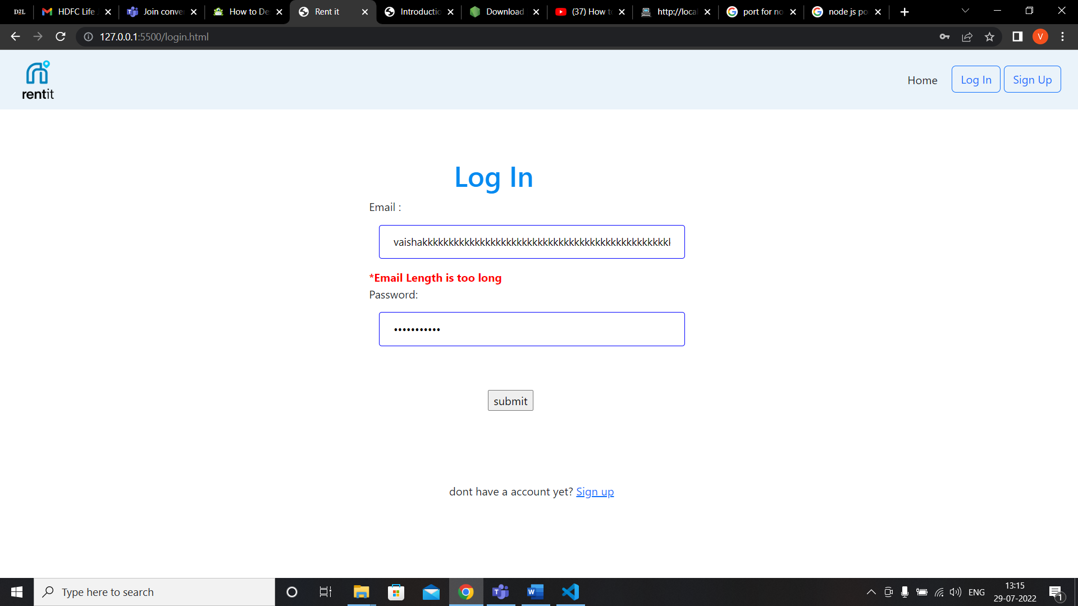

1. **Reservation Page :**

This page contains radio button to select type of car , energy type and number of days car required. And based on those inputs total rental money is calculated.

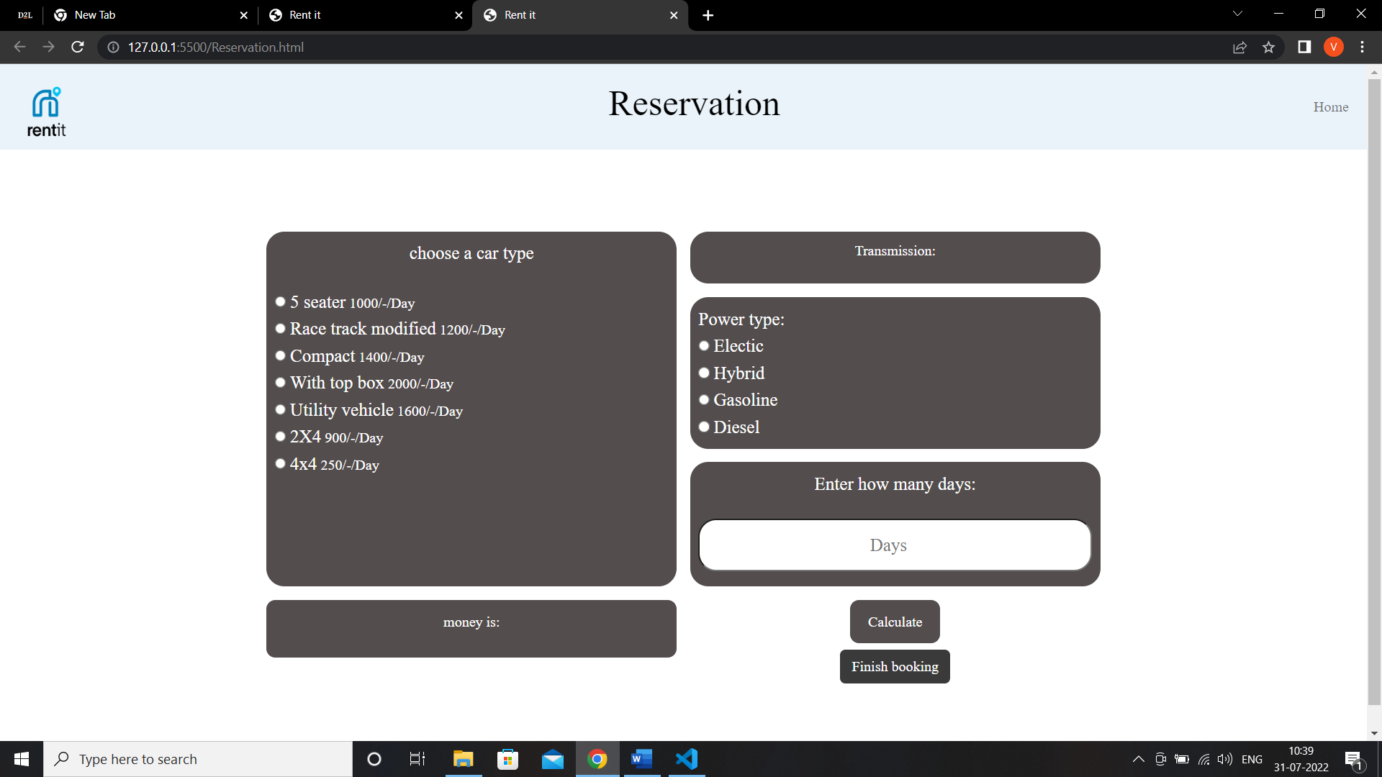

**Validations on reservation page :**

* Money is calculated only when all the fields are filled otherwise alert message is popped.

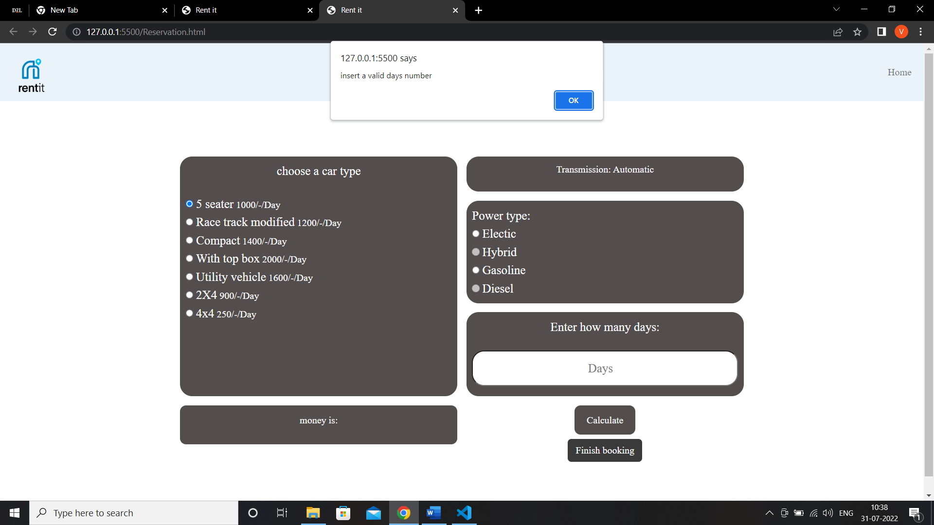

**Fig: Number of days not filled.**

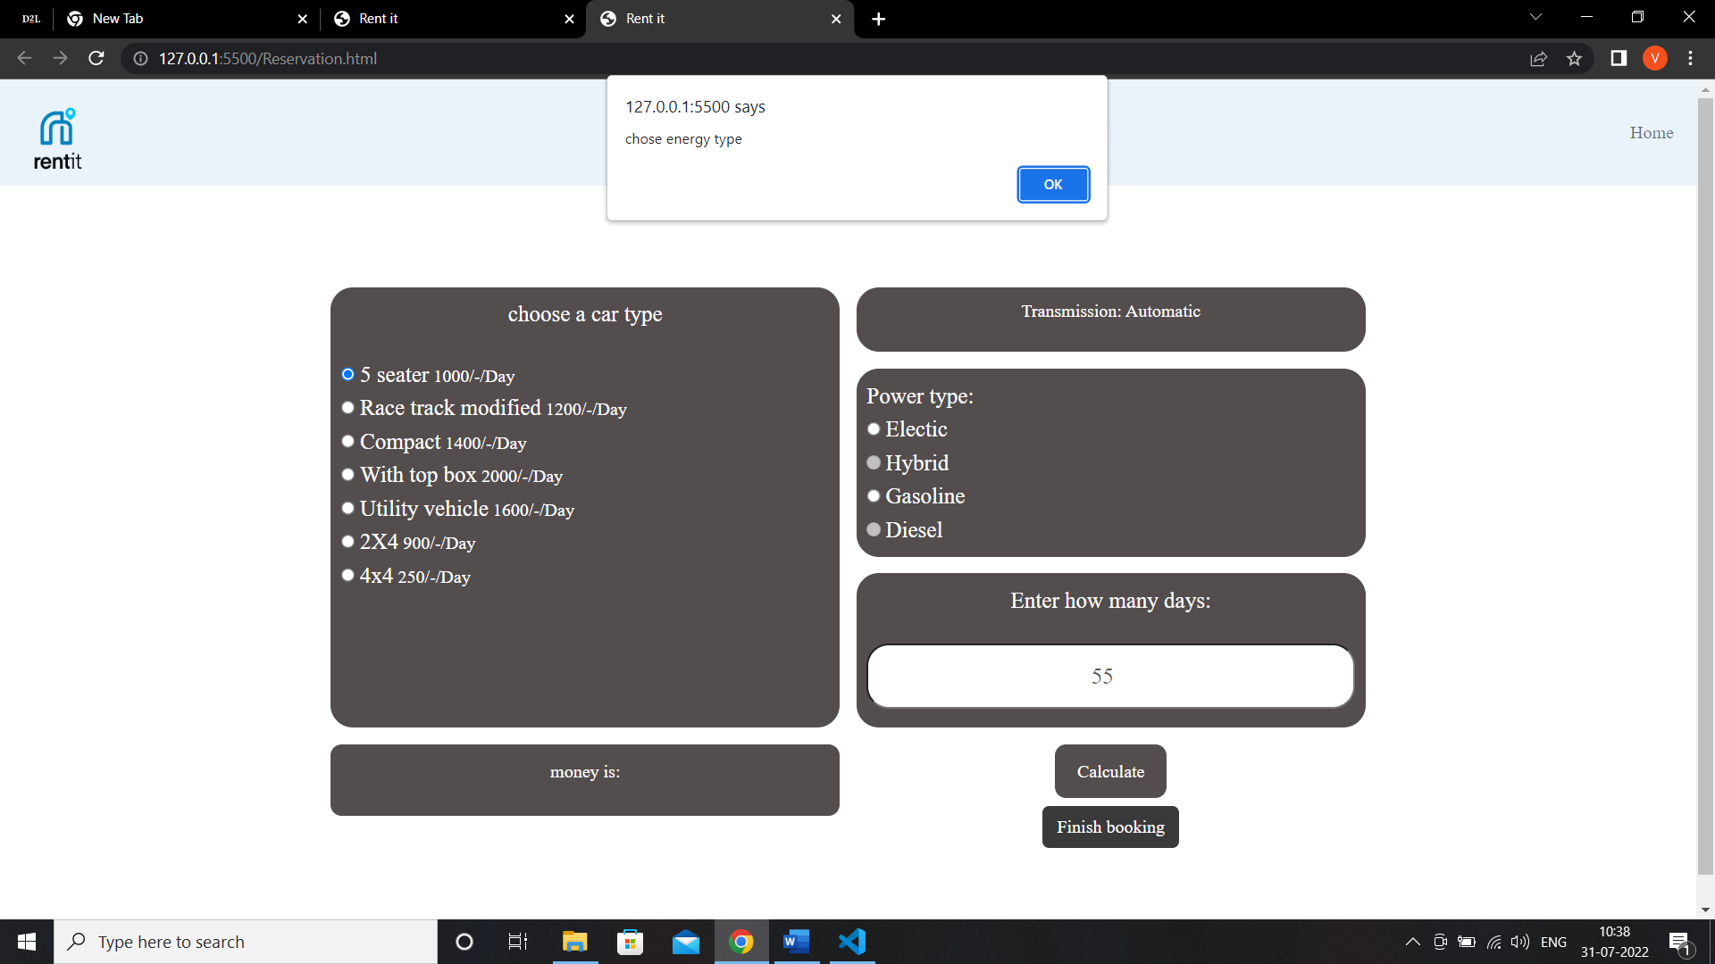

**Fig : When power type is not selected .**

**9.Thank you Page:**

Just the thank giving page . And telling the customer the team of RentIt will contact them soon.

**Screenshots:**

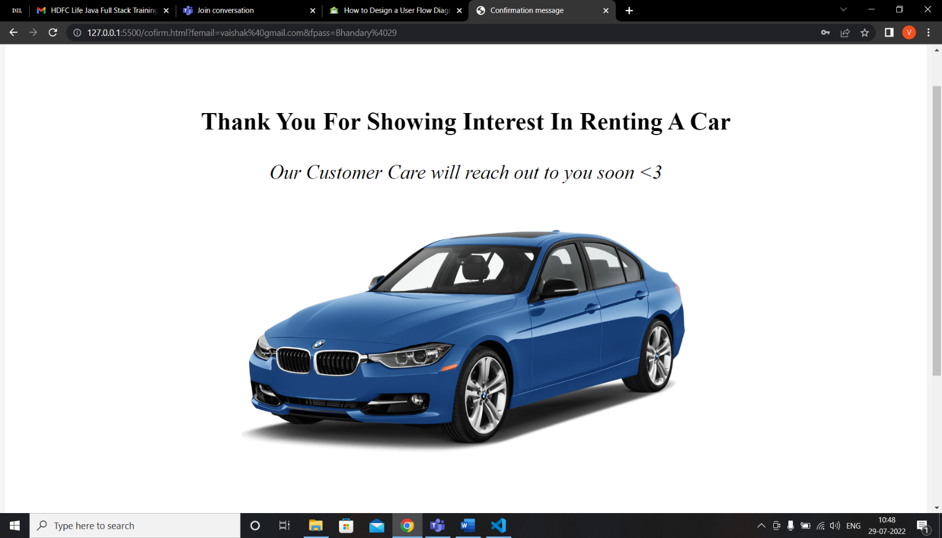

**Mobile view :**

**Screnshots :**

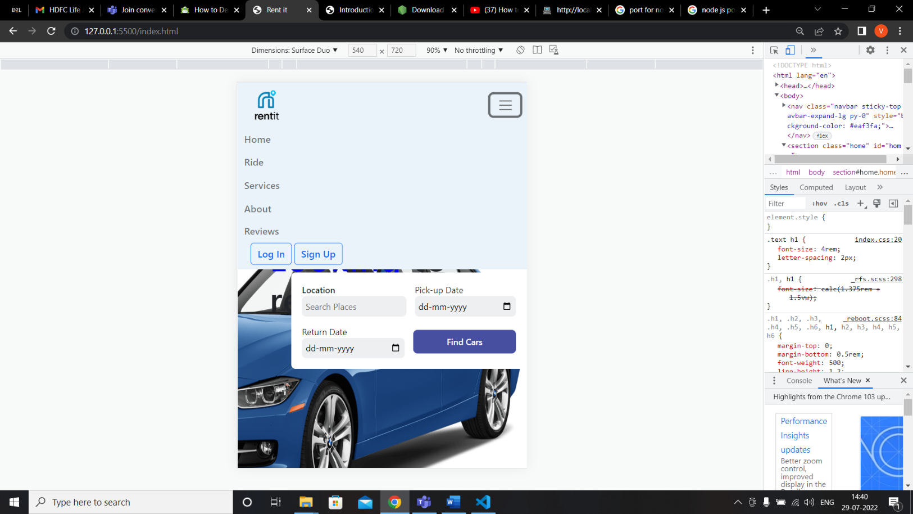

**Fig: Home page**

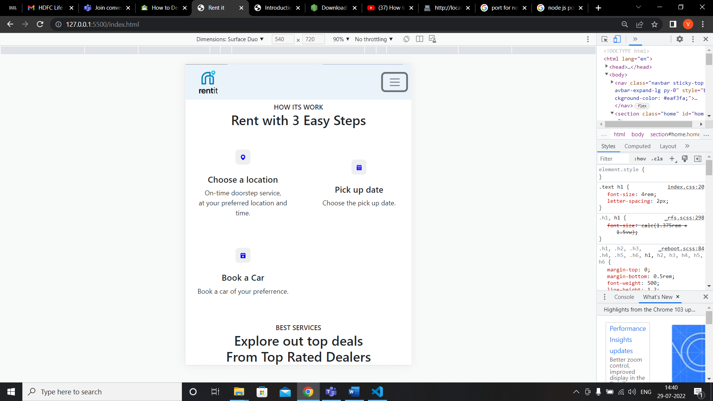

**Fig : Ride page**

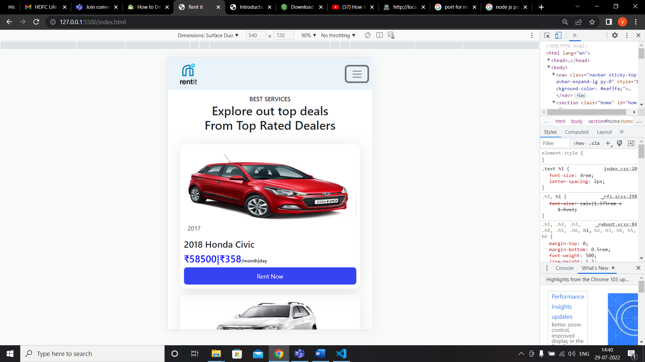

**Fig : Services Page**

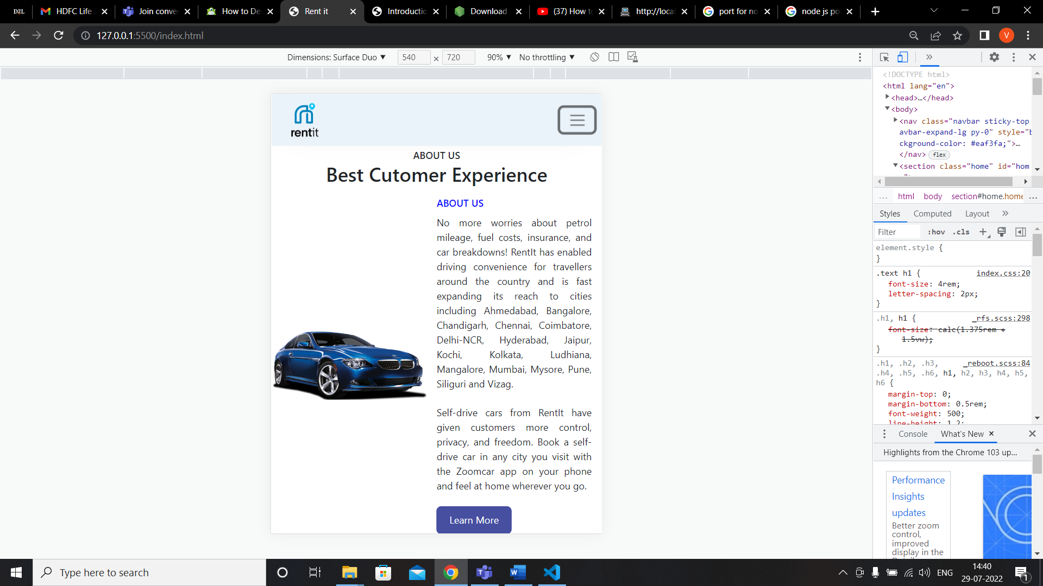

**Fig : About us Page**

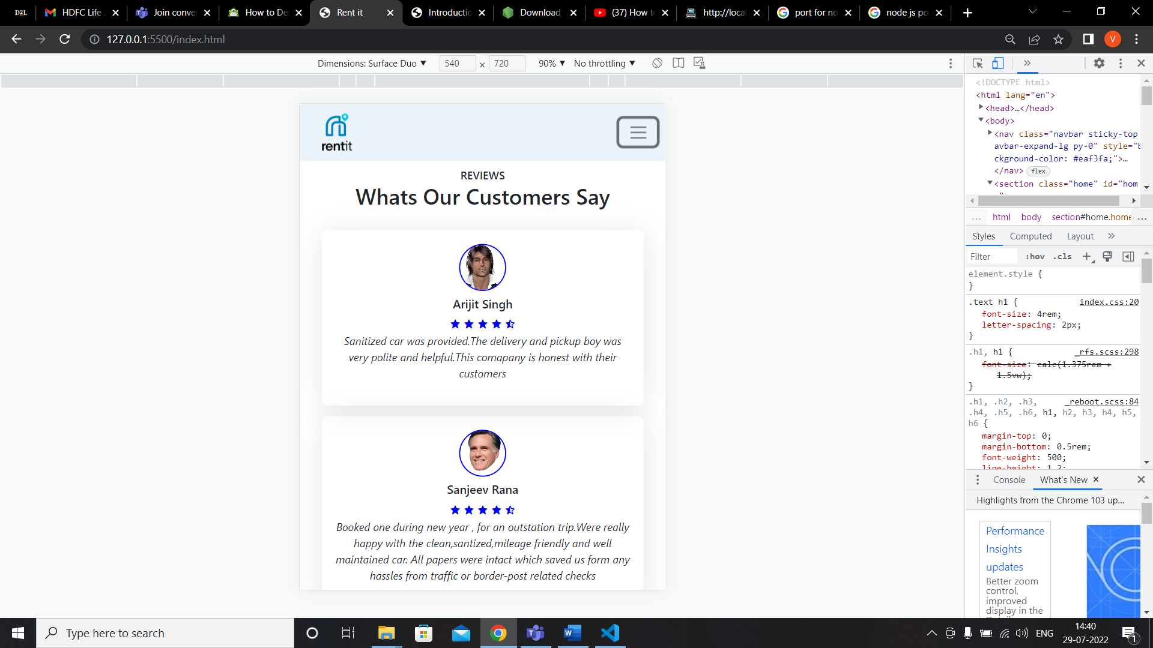

**Fig : Review Page**

**Website flow:**

Flow of the website how it works are defined step by step below:

**Step 1.Home Page :**



Here we can give the location of pick up , pick-up date and return date and click the find cars button. You will be redirect to the available cars list.

**Step 2 : Available Cars Section :**

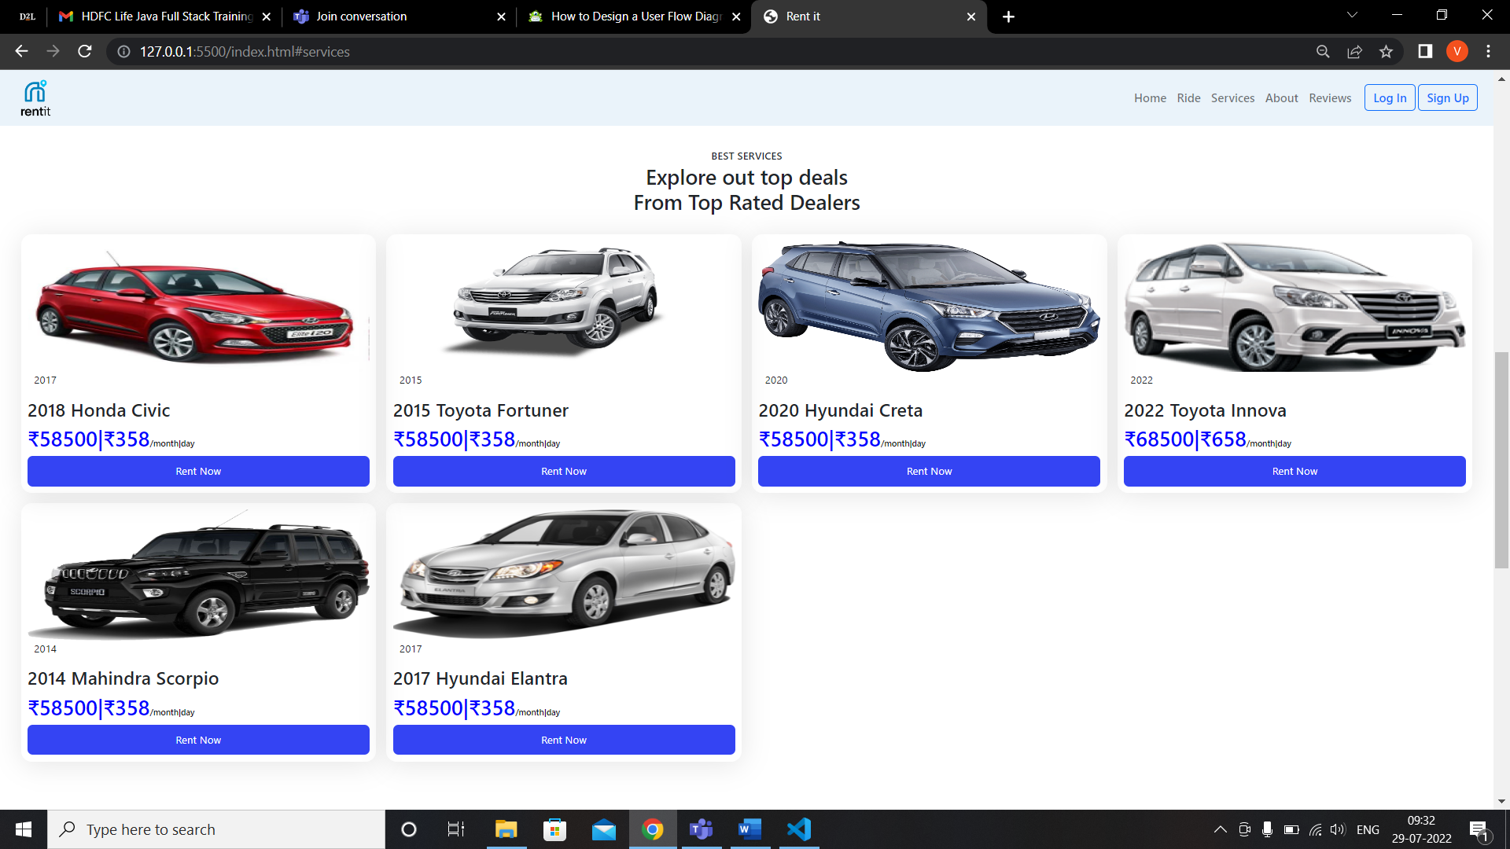

Once the list of available cars displayed you can click on the rent now button as shown in below image :

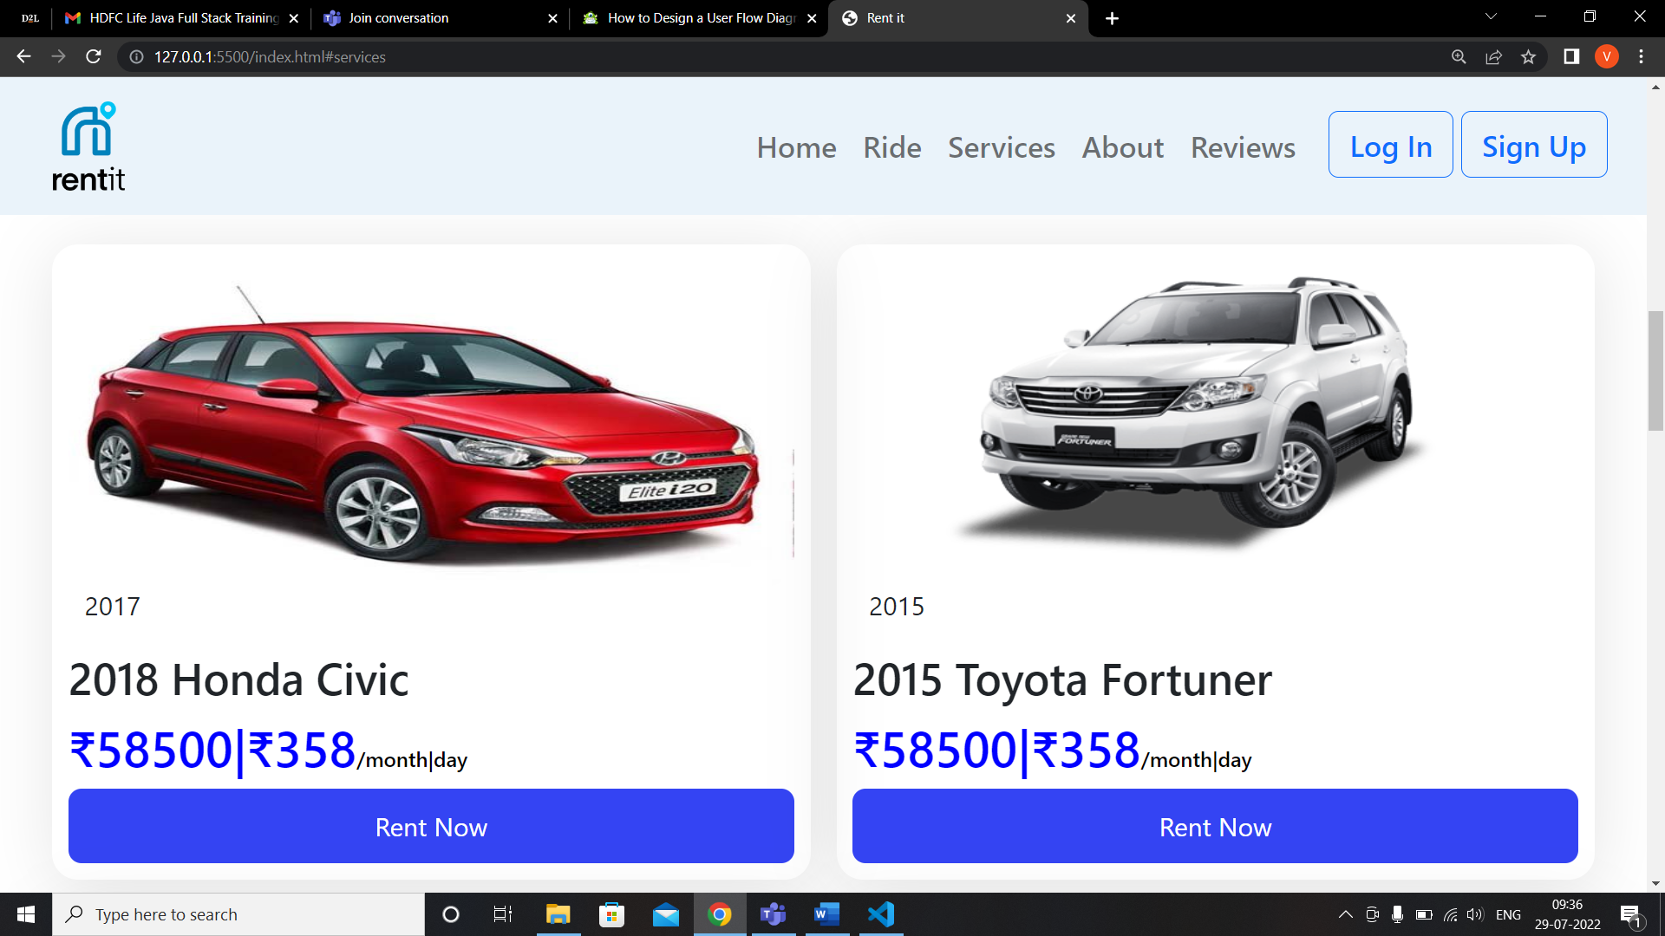

Once you click on the rent now button you be directed towards signup page to get your information.

**Step 3 : Sign up page :**



All the necessary fields have to be filled and client side validation will take place. If you already have an account you can login directly.

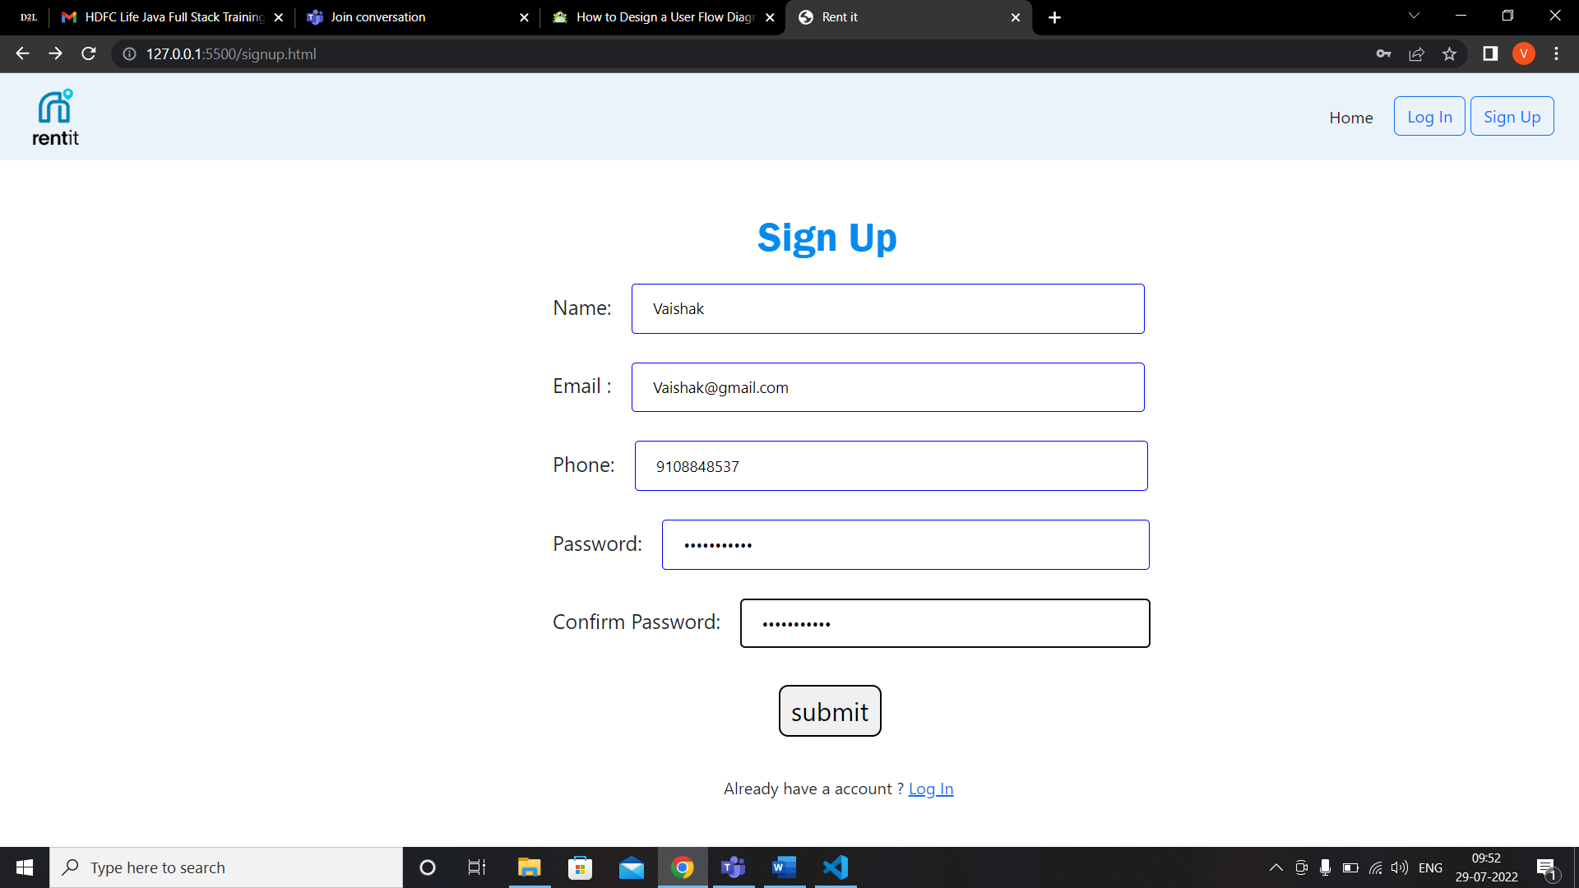

Once you filled all the fields and pass the validation .Submit is clicked you will be directed to login page.

Step 4 : Log In :



Fill the valid fields in the LogIn and submit . Once you submitted the reservation page is displayed.

Step 5 : Reservation Page :

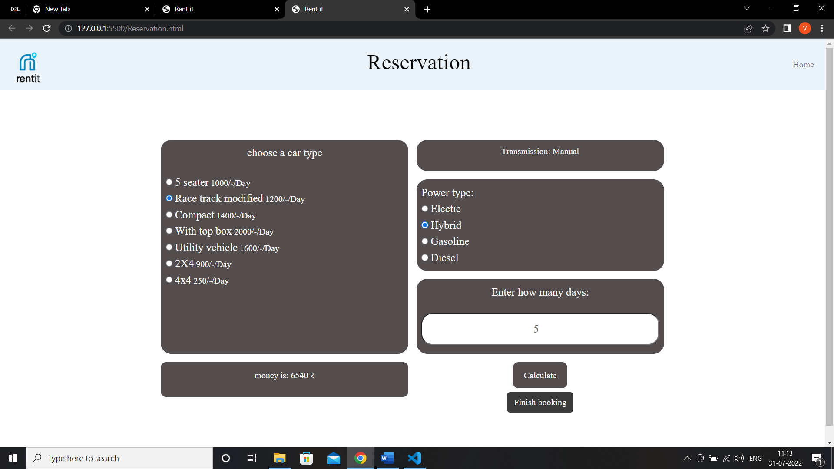

Once you fill all the fields in reservation page . The total amount is displayed based on the options selected.



Now click on the Finish booking button and confirmation pages is displayed.



Step 6: Confirmation page :



Thank you page is displayed and customer care will get back to the customer regarding the further processes .

**Conclusion :**

Online Car Rental Website reduce the time it takes to rent a car and the costs of hiring people to input data into paper-based records. Additionally, these systems allow rental car companies to track vehicles more efficiently and cut down on fuel expenses by eliminating unnecessary trips back to the office for information or paperwork. This project is efficient in maintaining the car and customer deatails and enables you to have accurate records of your entire fleet in one place, which makes day-to-day running smooth and easy..

**Github link :** <https://github.com/vaishakbhandary/RentIt>